**A few things during installation:**

* Had to install Windows Subsystem for Linux (I am pretty sure this is necessary). Accessible using bash (and pretty sweet). **Try maybe upgrading to WSL 2 (not sure if done)**
* Had to install at least 2 programs on the Linux subsystem (swig.exe and unzip)
* Used the docker shit, do not know if it worked since I still installed quite a lot by myself.
* Installed an awesome tool for Linux called dos2unix to fix all the endings which I saw were problematical.
* Got the following warning quite a few times, consider doing if things stop working:
  + WARNING: The scripts pysc2_agent, pysc2_play and pysc2_replay_info are installed in '/home/t8637523/.local/bin' which is not on PATH.
  + Consider adding this directory to PATH or, if you prefer to suppress this warning, use --no-warn-script-location.
  + **export PATH=$PATH:**/home/t8637523/.local/bin

**Helpful:**

* Show starcraft shit
  + python3 -m pysc2.bin.play --norender --rgb_minimap_size 0 --replay NAME.SC2Replay
* Train on starcraft
  + python3 src/main.py --config=qmix --env-config=sc2 with env_args.map_name=2s3z
* Train on MultiCartpole
  + python3 src/main.py --config=qmix --env-config=multi_cart

**Running Example of Starcraft**

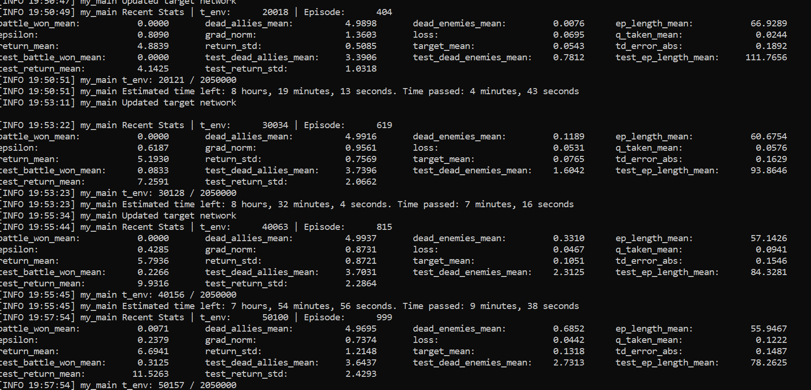

**Starcraft Environment**

* <https://github.com/oxwhirl/smac/blob/master/smac/env/starcraft2/starcraft2.py>

**Rewards Problem – they go for global rewards I think. Can be bypassed**

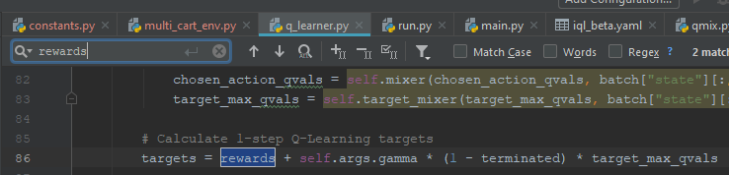

**Development steps:**

1. **Get the 5 networks working on the CartPole Example**
   1. **Visualize?**
2. **Make the Cartpole example Coupled**
3. Implement Global – Local Rewards. Sum up Local rewards for local
4. Implement Local Q-mix